**DOMINOS PIZZA SALES SQL QUERIES**

1. **Total Revenue:**

SELECT SUM(total_price) as TOTAL_REVENUE FROM pizza_sales

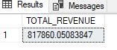

**2. Average Order Value**

SELECT SUM(total_price)/COUNT(DISTINCT order_id)AS Average_Order_Value FROM pizza_sales

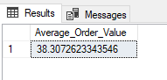

**3. Total Pizzas Sold**

SELECT SUM(quantity)as Total_Pizzas_Sold FROM pizza_sales

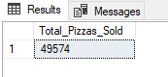

**4. Total Orders**

SELECT COUNT(DISTINCT order_id) AS Total_Orders FROM pizza_sales

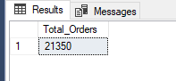

**5. Average Pizzas Per Order**

SELECT CAST(

CAST(

SUM(quantity)as decimal(10,2))

/CAST(

COUNT(DISTINCT order_id)as decimal(10,2))

AS DECIMAL(10,2))AS Average_Pizzas_Per_Order FROM pizza_sales

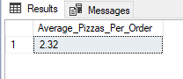

1. Daily Trend for Total Orders

SELECT DATENAME(DW, order_date) as Order_Day, count(DISTINCT order_id) as Total_Order

FROM pizza_sales GROUP BY DATENAME(DW, order_date)

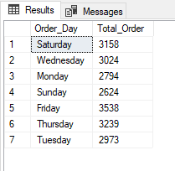

1. **Monthly Trend for Orders**

SELECT DATENAME(MONTH, order_date) as Month_Name, count(DISTINCT order_id) as Total_Order

FROM pizza_sales

GROUP BY DATENAME(MONTH, order_date)

ORDER BY Total_Order desc

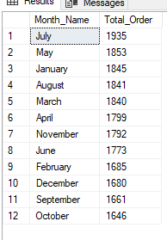

1. **Percentage of Sales by Pizza Category**

SELECT pizza_category, SUM(total_price) as Total_Sales, SUM(total_price)*100/

(SELECT SUM(total_price) FROM pizza_sales

WHERE MONTH(order_date)=1) AS Percentage_of_Sales_by_Pizza_Category

FROM pizza_sales

WHERE MONTH(order_date)=1

GROUP BY pizza_category

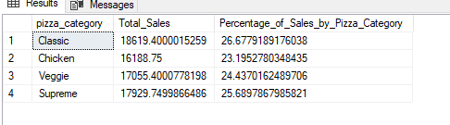

1. **. Percentage of Sales by Pizza Size**

SELECT pizza_size, CAST(SUM(total_price) AS DECIMAL(10,2)) as Total_Sales, CAST(SUM(total_price)*100/

(SELECT SUM(total_price) FROM pizza_sales) AS DECIMAL(10,2))

AS Percentage_of_Sales_by_Pizza_Category FROM pizza_sales

GROUP BY pizza_size

order by Percentage_of_Sales_by_Pizza_Category desc

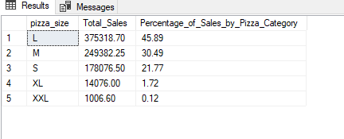

1. **Total Pizzas Sold by Pizza Category**

SELECT pizza_category, SUM(quantity) AS Total_Quantity_sold FROM pizza_sales

GROUP BY pizza_category

order by Total_Quantity_sold desc

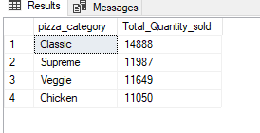

1. **Top 5 Pizzas by Revenue**

SELECT TOP 5 pizza_name, SUM(total_price) AS Total_Revenue FROM pizza_sales

GROUP BY pizza_name

ORDER BY Total_Revenue DESC

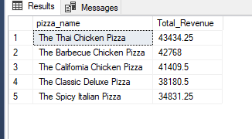

1. **Bottom 5 Pizzas by Revenue**

SELECT TOP 5 pizza_name, SUM(total_price) AS Total_Revenue FROM pizza_sales

GROUP BY pizza_name

ORDER BY Total_Revenue asc

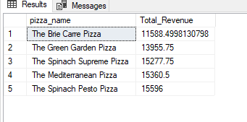

1. **Top 5 Pizzas by Quantity**

SELECT TOP 5 pizza_name, SUM(quantity) AS Total_Quantity FROM pizza_sales

GROUP BY pizza_name

ORDER BY Total_Quantity desc

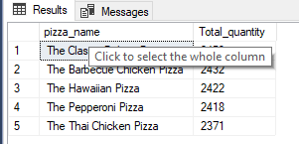

1. **Bottom 5 Pizzas by Quantity**

SELECT TOP 5 pizza_name, SUM(quantity) AS Total_Quantity FROM pizza_sales

GROUP BY pizza_name

ORDER BY Total_Quantity asc

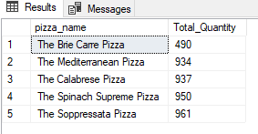

1. **Top 5 Pizzas by Total Orders**

SELECT TOP 5 pizza_name, COUNT(DISTINCT order_id) AS Total_Order FROM pizza_sales

GROUP BY pizza_name

ORDER BY Total_Order desc

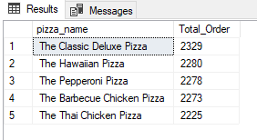

1. **Borrom 5 Pizzas by Total Orders**

SELECT TOP 5 pizza_name, COUNT(DISTINCT order_id) AS Total_Order FROM pizza_sales

GROUP BY pizza_name

ORDER BY Total_Order asc

